

Travlr Getaways

CS 465 Project Software Design Document
Version 1.0

Table of Contents

CS 465 Project Software Design Document 1
Table of Contents 2
Document Revision History 2
Instructions 2
Executive Summary 3
Design Constraints 3
System Architecture View 3
Component Diagram 3
Sequence Diagram 4
Class Diagram 4
API Endpoints 4
The User Interface 4

Document Revision History

Version | Date | Author | Comments
1.0 | 05/25/25 | July Wellman | Completed sections Executive Summary, Design Constraints, & System Architecture

Executive Summary

For a travel-based website, I recommend using MEAN stack for development. This website will be a client-server. Mongo DB will be the database which will serve as a great foundation for flexibility and scalability in the future. Node.js and Express.js will manage the backend logic while the front end will be developed using Angular. The website will use a Single-Page Application (SPA) that will allow us to streamline tasks, such as user or inventory management among many others. With this architecture, we can create an efficient and scalable web application.

Design Constraints

With the application being built with a MEAN stack, MongoDB is a NoSQL schema, so structured relationships will need attention in management. In addition to this, because the web application will run on a MEAN stack, all components added to the website will need to be compatible with the MEAN stack. The system will also need to be designed with a scalable database to support high traffic during peak seasons in travel. Using server-side caching to get quicker response times and optimizing better quality images not at the sacrifice of performance.

System Architecture View

Component Diagram

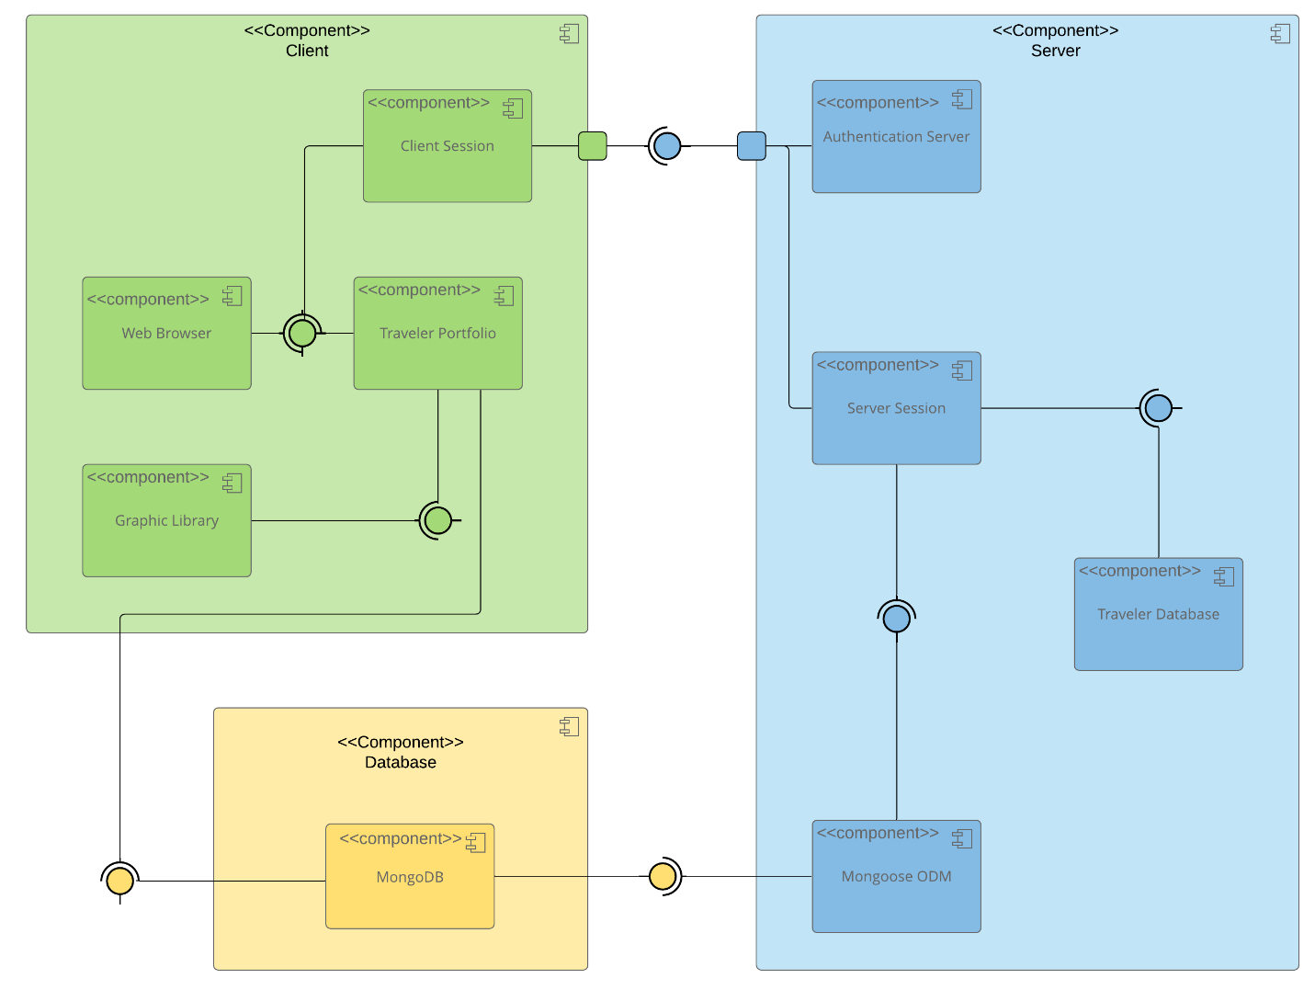

A text version of the component diagram is available: CS 465 Full Stack Component Diagram Text Version.

In the Diagram above there are three components consisting of the client, server, and database. Each component has sub-components that the main component is able to access. The Client serves as the front-end using Angular. From the front end, the client can start a session on the web browser to navigate and communicate with the UI to make requests on the backend. The server is the backend ran by Node.js and Express.js. These two handles the logic and requests created by the client and server. MongoDB is the database that houses all of the data being exchanged between the two.

Sequence Diagram

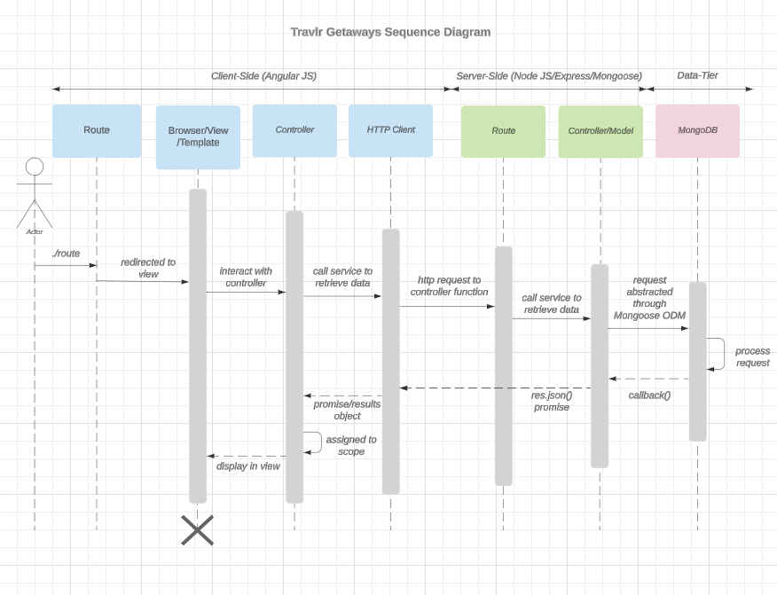

The user, or actor, signs in to a specific browser, view or template. The browser, views and templates interact with the controllers to then call data retrieval from the HTTP client. This then passes from the client side (Angular JS) to the server side (Node JS/Express/Mongoose) where the router (Express) routes the HTTP request to a controller. The controller takes the request and interacts with the model (Mongoose) to retrieve and verify data retrieval and credentials directly with MongoDB. Mongo DB handles the data request and passes the information back to Mongoose where the data will travel back through the server-side to the client-side back to the user.

Class Diagram

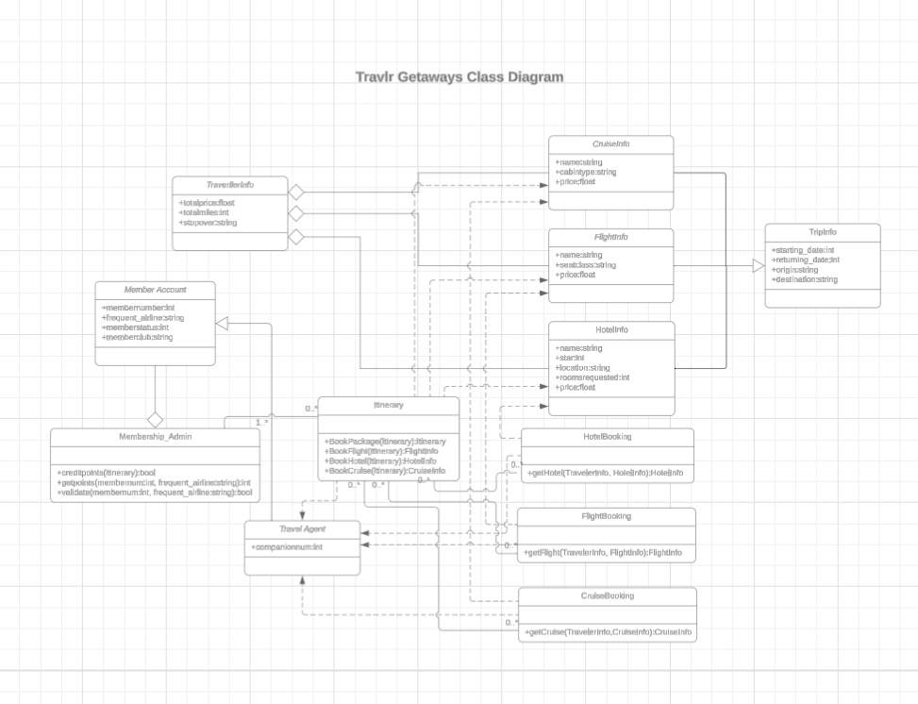
Trip Info:
Shows the trip information including the starting date, returning date, origin, and destination.
Member Account:
Holds the memberships details including the member number, frequent airline, membership status, and member’s club.
Membership Admin:
Membership Admin inherits the Member Account. Members can credit points, get points, and validate for the member number and frequent airline.
Travel/Agent:
Manage bookings with companions
Itinerary:
Managing and organizing trips. Members can manage or get information on packages, flights, hotels, and cruises.
Hotel Booking:
Used to book a hotel with traveler info.
Flight Booking:
Used to book a flight with traveler info.
Cruise Booking:
Used to book a cruise with traveler info.
Traveler Info:
It shows the traveler info including total price of the cost, total miles, and stopovers. Members can specify which filter they would like to see.
Flight Info:
Members can filter to show the name, seat class, and price of the flight
Hotel Info:
Members can filter the name, start, location, rooms requested, and price for the hotel
Cruise Info:
Members can filter the name, cabin type, and price of the cruise.

API Endpoints

<Exposing RESTful endpoints is a design approach to enable an application to participate in a larger ecosystem. Document each endpoint in the table below, including the HTTP method, purpose, URL, and notes.>

Method | Purpose | URL | Notes
GET | Retrieving the list of trips | </api/trips> | Returns all trips
GET | Retrieve Gale’s Reef | </api/trips/GALR210214> | Returns a single trip. In this instance, it was the Gale Reef Trip.

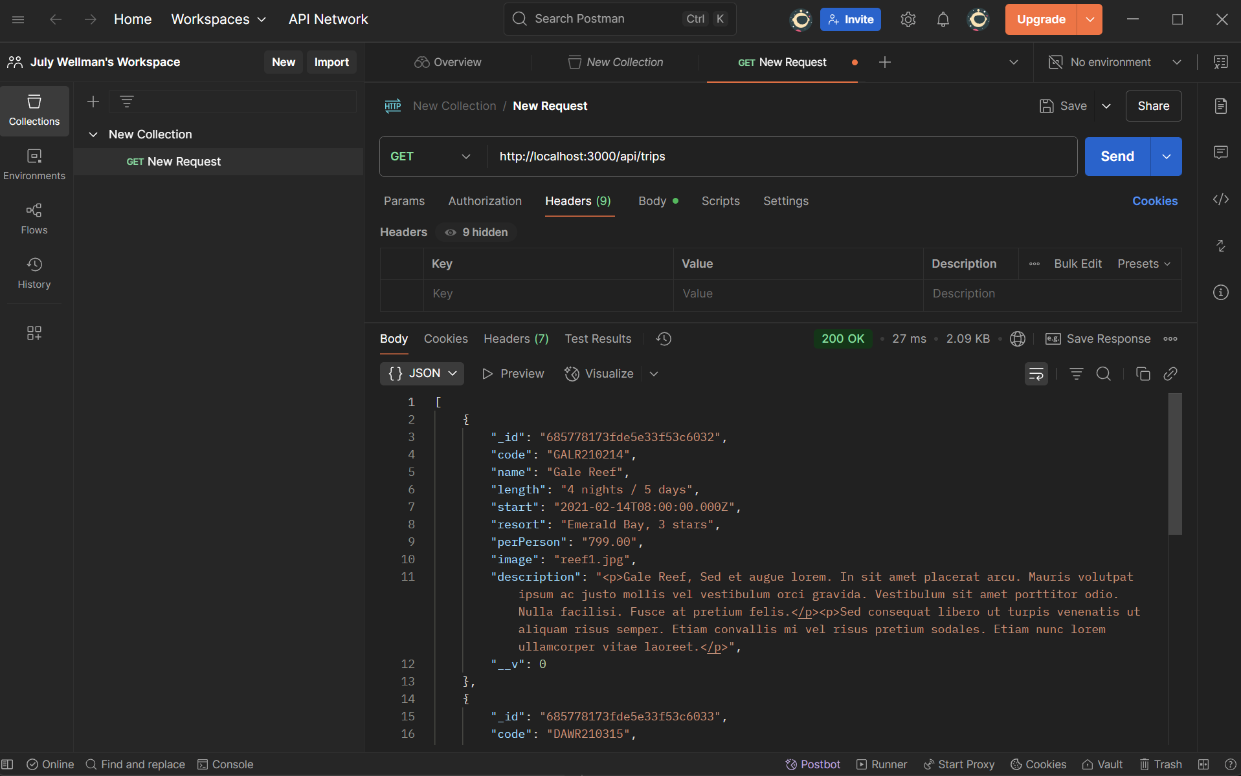
GET list of trips

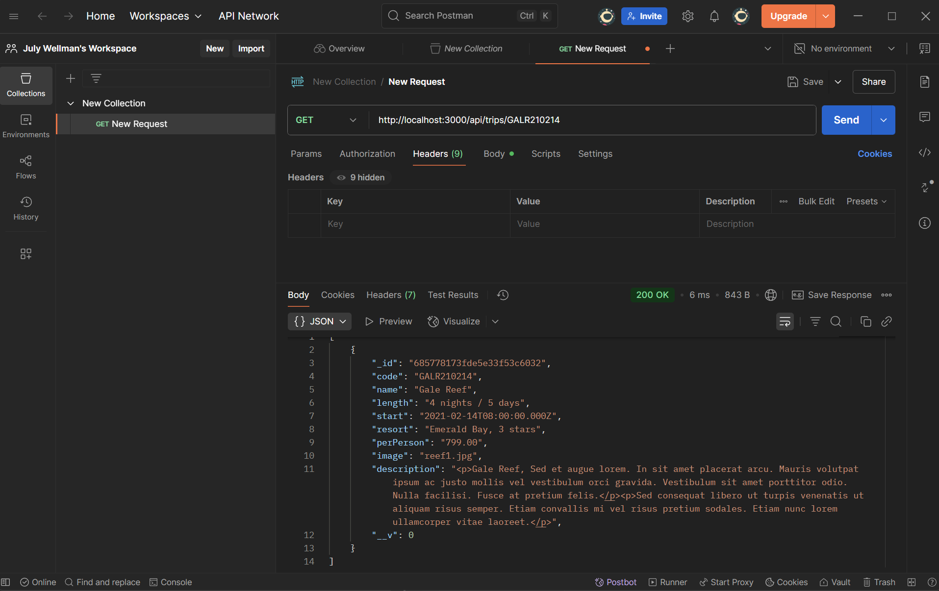
GET trip info for Gale’s Reef

The User Interface

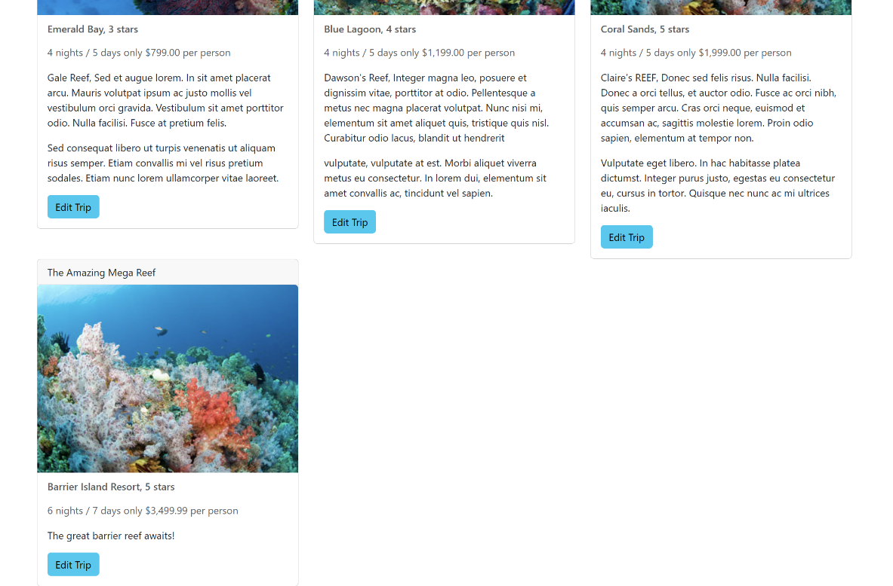Unique trip added

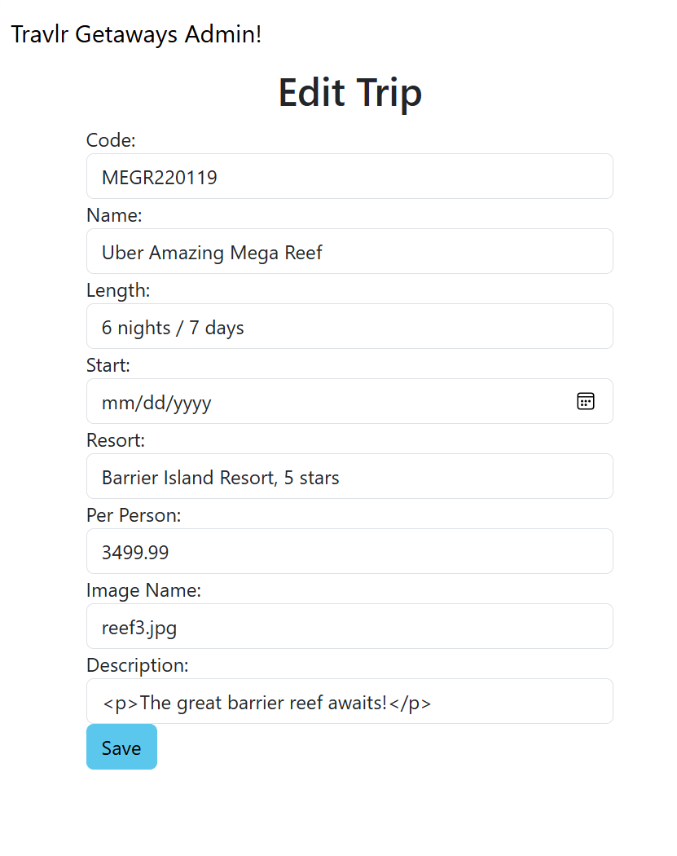Edited to Uber Amazing Mega Reef
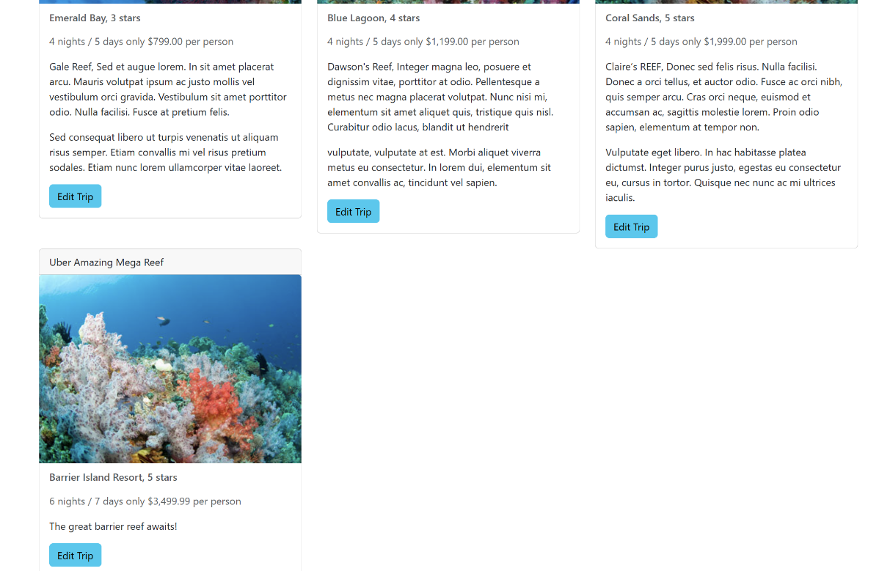Updated screen

Travlr Journal
The Angular project structure is different from an Express HTML customer-facing page by many features. Angular uses a modular structure containing the main code inside the src/app/ folder. This folder contains trip components, services, and many others. These files are then broken down into .ts, .html, .css, and .spec.ts. I got practice with this feature in creating the add-trip and edit-trip.components. Angular seemed more gear at the admin features as to Express more geared towards the customer facing end. Express loaded in static HTML templates and felt like the end user experience. The use of the RouterModule feature in Angular was a nice feature to not have to reload a full page. Express uses server-side routes such as app.get or app.post resulting in a new page.
Advantages to SPAs are their reduced loading times resulting in better user experience. Dynamic updates add to a better user interface. Disadvantages are creating complex systems that can be vulnerable to security threats. According to Medium, “SPAs can be vulnerable to certain security issues, such as Cross-Site Scripting (XSS) attacks if not properly secured. Developers need to pay extra attention to security measures when building SPAs to protect against potential threats.” (Vaishak, 2023). Additional functionalities I experienced with SPAs were real-time debugging without having to close out of app-admin server. The debugging screen was a helpful tool in identifying errors in routing or code.
The errors I ran into with SPAs were that I was running a higher version so when I created my files, they populated without the .component in any of the files. It initially threw me off since all the guides ran on the older version. I should have investigated rolling back the version, but I renamed the files as I went along. I got stuck on many routing errors due to the .component naming convention, but at least I learned a lot about how this works and ties in with other components and services within the code. I used Postman to assesses the GET and PUT routes. I tested the list of trips and edited trips. I also tested the HTTP requests to make sure requests are sent and received. Issues I initially ran into were not understanding that both the app-admin server and Express needed to be up at the same time. I used MongoDB Compass to delete a trip I created to test the routing between the database and the SPA. Most of the time was spent just figuring out the placement of code formatting and understanding what file effects the other.
I learned an overwhelming amount of knowledge in this module. I have a much better understanding of SPAs and the modules, components, and services work. A question I have is how to keep SPAs secure? I am sure there will need to be some kind of authentication or authorization. What about roles and restricted access to a SPA?

References
Vaishak. (2023, November 1). The pros and cons of single-page applications (SPAs). Medium.
The Pros and Cons of Single-Page Applications (SPAs) | by VAISHAK | Medium

